

Liquid Rock

**Lesson plan**

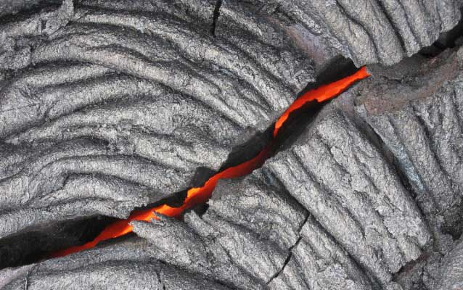

**GRADE LEVEL:**

Fourth Grade - Eighth Grade

**SUBJECT:**

Earth Science, Geology, Physical Science, Volcanoes

**DURATION:**

1 - 2 hours

**GROUP SIZE:**

Up to 36

**SETTING:**

Classroom

**NATIONAL/STATE STANDARDS:**

NGSS.SEP.2, NGSS.SEP.6

PS1-5-3, PS1-MS-1, PS1-MS-2, ESS2-MS-1

**Overview**

Students learn about the properties of lava by experimenting with liquids having varying gas contents and viscosities. (CLASSROOM ACTIVITY) 

**Objective(s)**

* Students will be able to describe liquids in terms of their viscosity.
* Students will be able to explain how heat affects a liquid's viscosity.
* Students will understand how dissolved gas and pressure influence the behavior of an eruption.

**Background**

When we think about the properties of liquid, water usually comes to mind. But there are many different liquids, each with unique freezing points, boiling points, and viscosities. A liquid's behavior can also be greatly modified by the presence of dissolved gases (e.g., soda vs. water).

Craters of the Moon was once a liquid sea of lava (although not all at once) until it "froze" and turned to a solid. Early eruptions were violent, like a shaken can of soda, while later eruptions were sedate, like water being poured into a glass. Some lava raced across the land like heated olive oil, while other flows crept along like tons of tepid toothpaste.

Two basic types of lava made Craters: rhyolite and basalt. The main difference between the two is the amount of silica (SiO2) they contain. Rhyolitic lava's high silica content causes it to be quite viscous. That viscosity prevents gas within it from readily escaping as the magma rises to Earth's surface through a break in its crust. When lava can no longer contain the increasing gas pressure within, cataclysmic rhyolitic eruptions occur.

Basaltic eruptions are gentler because gas bubbles to the surface before it generates explosive pressure. Boiling water does not cast large volumes of liquid into the air in violent fits and starts like, for example, a boiling vat of mud. The high viscosity of the mud causes it to behave like rhyolitic lava. Basaltic lavas are runnier, like maple syrup, while rhyolitic lavas are more like molasses.

Early volcanic activity in the Snake River Plain (up to 17 million years ago) consisted of calamitous rhyolitic eruptions that created enormous calderas up to several 100 miles square miles in area! At Craters this evidence has since been entirely hidden by the more recent, gentler, and generally low-silica basaltic eruptions. Almost all the rock you see at Craters is basalt.

Very hot basalt, whose top layered cooled like the "scum" at the surface of a mug of hot chocolate, became the smooth, ropy lava we call pahoehoe. Cooler lava that crept downhill and was slowly turned, twisted, and ground up into irregular chunks became a’a.

See "Additional Resources" below for links to introductory materials about the geology of Craters of the Moon.  
  
From the *Teacher's Guide to Craters of the Moon.*

**Materials**

* Two empty film canisters (black with gray lid)
* Alka-seltzer tablets (about 30)
* Bunsen burner, hot plate, or camp stove (optional)
* A pot for water (optional)
* Balloons, smallest available (one per 2-3 kids)
* Means to fill balloons part-way with water
* A bottle of carbonated mineral water
* Thermometer
* Watch with second hand
* Several liquids with different viscosities (e.g., water, cooking oil, honey, syrup, corn syrup, molasses, water, or mayonnaise)
* A smooth surface such as a lunch tray or a dry erase board

**Procedure**

**PART 1 Demonstrate Gas Pressure**

As an attention grabber and to introduce volcanism and the effects of gas and pressure, prepare the following experiment. Fill a film canister 1/4 to 1/3 full of water. Drop an Alka-seltzer into the canister and put the lid on and place a second, empty canister on top of the first. You might do this surreptitiously and begin talking about gases, liquids, and solids. In a few seconds the increasing pressure within the canister will cause it to "erupt", blowing the cap and the empty canister into the air getting everyone's attention. Alka-seltzer ooze may overflow the container just as lava might move down the slopes of a volcano.

Ask the students what happened. Gas was released when the Alka-seltzer came into contact with water. Gas occupies a greater volume than liquid or solid, so pressure increased within the canister until the lid could no longer contain it.

Show the class a bottle of carbonated mineral water or soda. Carbon dioxide (a gas at normal temperature and pressure) is dissolved in water. Shake it up and remove the cap. The liquid that bubbles out of the mouth of the bottle shows that the carbon dioxide within is quickly expanding now that its pressure has been released. The carbon dioxide expands, wreaking havoc just like the expanding gas in a rhyolitic volcanic eruption.

Ask the kids what happens to a pot of water sitting on a cold stove. Nothing much. What happens when you turn the heat on? The water approaches its boiling point and turns to gas. Where does the gas go? It escapes as steam. If you have a Bunsen burner, a hot plate, or a camp stove you could boil water and demonstrate this to the class as you discuss it. What would happen if you screwed the lid on tight? Increasing temperature and pressure within the pot would eventually cause it to blow up, spraying scalding water all over!

Ask the students what they know about the different states a substance can have: gas, liquid, solid. See what they know about water's three states: gaseous water, liquid water, and ice. Can they describe what happens to water when its temperature goes from -1° to +1°C. (31° to 33°F.)? From 99° to 101°C. (211° to 213°F.)? [Note: At 6000 ft, water boils at 200.6°F]

Hold up a rock. Ask the class if it will melt. Yes, at a high enough temperature it would. After all, the rock at Craters was once liquid. Will it turn to gas? In laboratory conditions under ultra-high temperatures its mineral parts would vaporize. But in nature the rock would not "boil" or reach its vapor point to any significant measure.

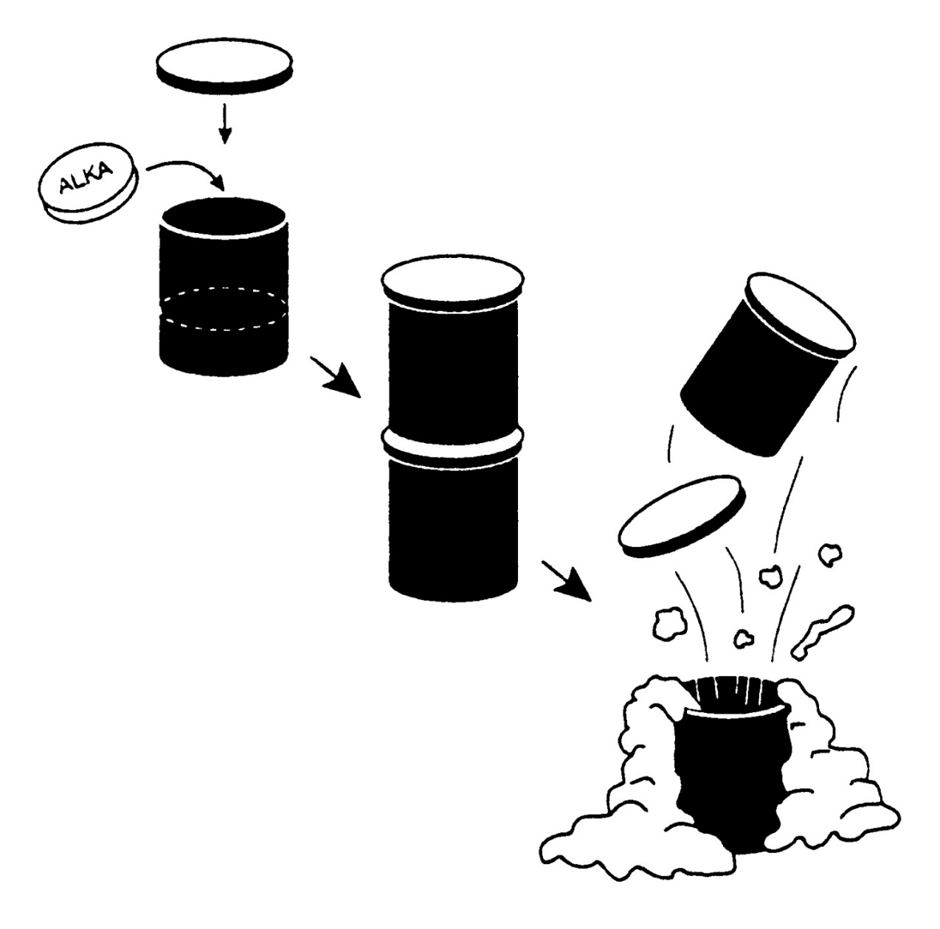

**PART 2: Alka-Seltzer and Balloon Experiment**Now it's time to let the students see for themselves the effects of gas and pressure. Go outside and give each of the students (or groups of 2-3 students) a small balloon and one or more Alka-seltzer tablets (you will need to experiment Beforehand to see how much water and how many tablets result in the desired effects with your particular type of balloons).

Have the students first break up an Alka-seltzer tablet and stuff the pieces into the neck of a balloon. Then add a little water and quickly tie off the neck. They will see the balloon expand as the gas within the tablet is released, similar to expanding gas in rising lava. Some kids could experiment with more than one tablet and varying amounts of water in the balloon. You could also let students repeat the film canister experiment you did at the beginning of the lesson.

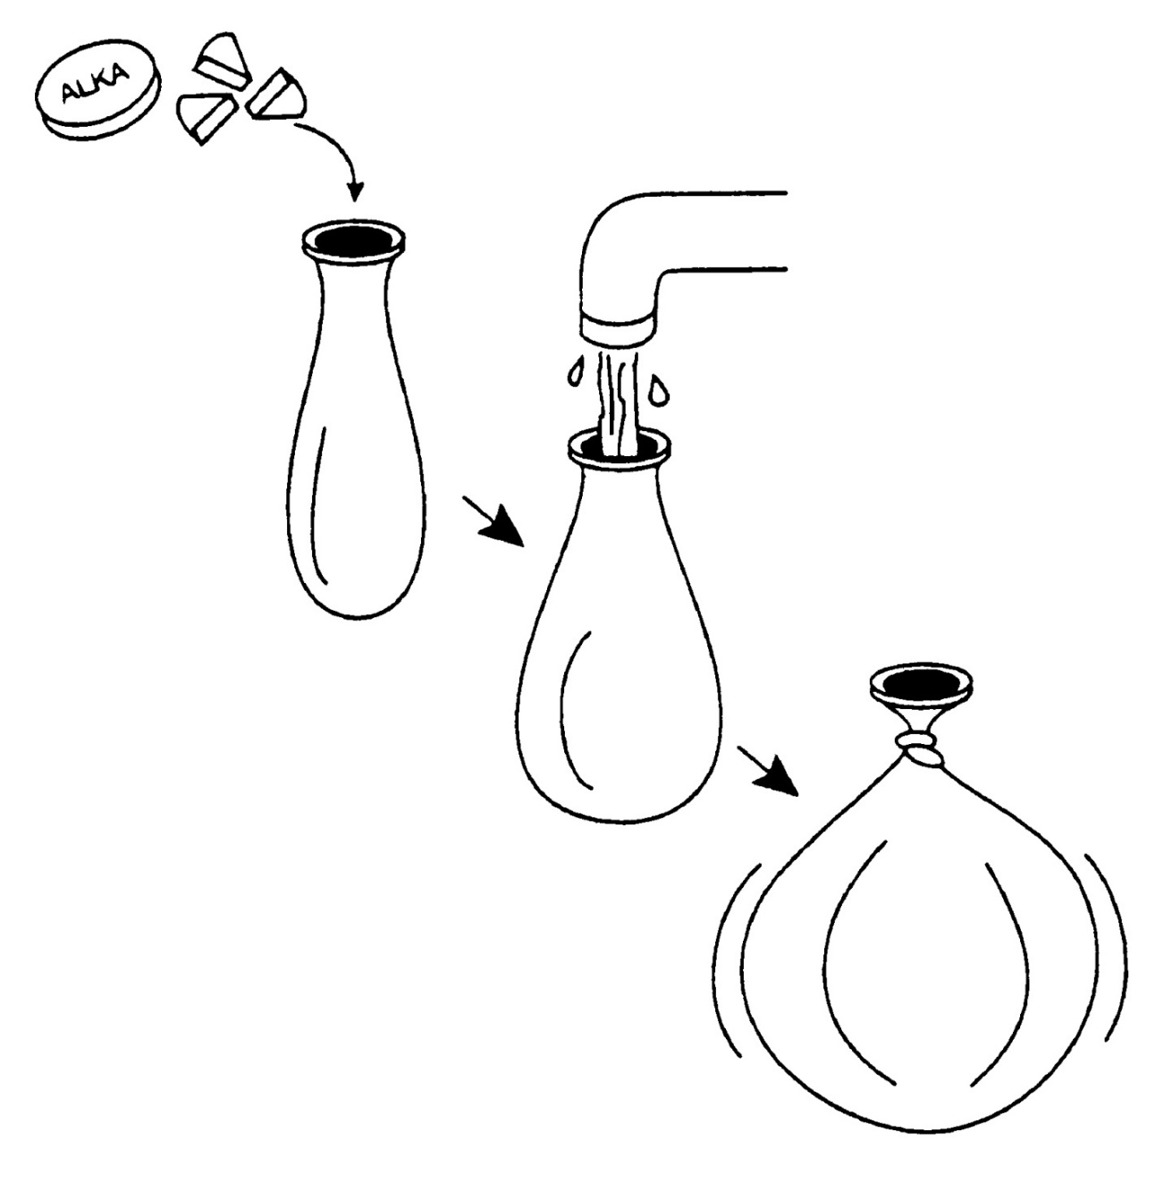

**PART 3: Viscosity Study**  
Place two lines on your smooth surface, labeling them A and B (see figure 1). You will measure the time it takes your liquids to go from A to B when the flat surface is held on an incline. Test each substance at different temperatures. For example, you could set one jar of honey in the sun or over a heating duct and another in a refrigerator until ready to do the experiment. Number the viscosities from least viscous (most runny) to most viscous (thickest) with 1 being the least viscous.

Using the following table, record the viscosity experiment data as a class or in small groups. Pretend that your liquids are actually different lavas at varying temperatures. Record whether your liquid contained lots of silica (high viscosity) or little silica (low viscosity).

|  |  |  |  |  |
| --- | --- | --- | --- | --- |
| **Liquid** | **Temperature** | **Time** | **Viscosity Rating** | **Silica** |
| (Sample) |  |  |  |  |
| Water | 50°F | 2 sec | 1 | low |
| Water | 90°F | 2 sec | 1 | low |
| Honey | 50°F | 30 sec | 4 | high |
| Honey | 75°F | 8 sec | 3 | high |
| Vegetable Oil | 75°F | 4 sec | 2 | med |

How did temperature affect viscosity? Did your warm honey or molasses cool noticeably as it slid down the surface? If so, did it look different at the bottom than it did at the top? Did any of your materials get that ropy, pahoehoe look? If you used a refrigerator and had more time would any of your sugar-containing liquids crystallize and become like jagged a’a lava?

### illustration of a flat board with several liquids of varying viscosity running down the board from a line labeled A to a line labeled B

### Additional Resources

[Geology for Teachers](http://www.nps.gov/crmo/forteachers/geology-for-teachers.htm)  
[Geology for Students](http://www.nps.gov/crmo/forteachers/geology-for-students.htm)  
[Glossary](http://www.nps.gov/crmo/forteachers/glossary.htm)  
[Analogs](http://www.nps.gov/crmo/forteachers/analogs.htm)

**Vocabulary**

Viscosity: The state of being thick, sticky, and semifluid in consistency, due to internal friction.  
Gas pressure: The force exerted by gas particles colliding with the wall of their container.